Technical Solution

Introduction

This project consists of 7 units and 6 forms and is linked to a Microsoft Access database which contains 8 tables

The Units are shown below:

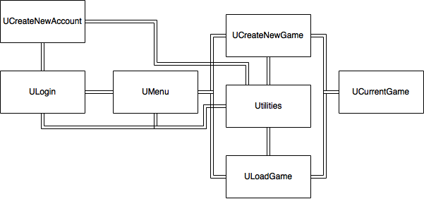

|  |  |  |  |  |
| --- | --- | --- | --- | --- |
| **Unit** | **Associated Form** | **Uses (Linked to)** | **Tables used** | **Description** |
| ULogin | FmLogin | Utilities |  |  |
| UCreateNewAccount | FmNewSeason | Utilities |  |  |
| UMenu | FmFixtures | Utilities |  |  |
| UCreateNewGame | FmAddTeam | Utilities |  |  |
| ULoadGame | FmSetUpTeam | Utilities |  |  |
| UCurrentGame | FmEnterScores |  |  |  |
| Utilities | - | - | - | Library of general routines and store records and arrays |

Complex Procedures

|  |  |  |
| --- | --- | --- |
| Identifier | Description | Page |
| Procedure |  |  |
| Function |  |  |
| Unit - Utilities |  |  |

Appendix - Annotated listings of program code

(Just show some sections to show the types of comment that you should include.)

